EGN5442
Term Project Report
Christina Carbajal
Hitika Ghanani

Introduction

- The dataset consisted of 5000 movies separated into two files, credits and movie information. For part A, only a subset of the movie information was used for simplicity. Both datasets were used for the movie recommendation system instead. Both datasets were preprocessed through various methods such as converting categorical values into numerical values, aggregating data to create count columns, merging data based on id values, and dropping null or nonsensical values.

- The correlation matrix created in part A showed no severe signs of high correlations between features, other than the columns that were aggregated from other columns. Therefore, the columns within the subset were kept in the model.

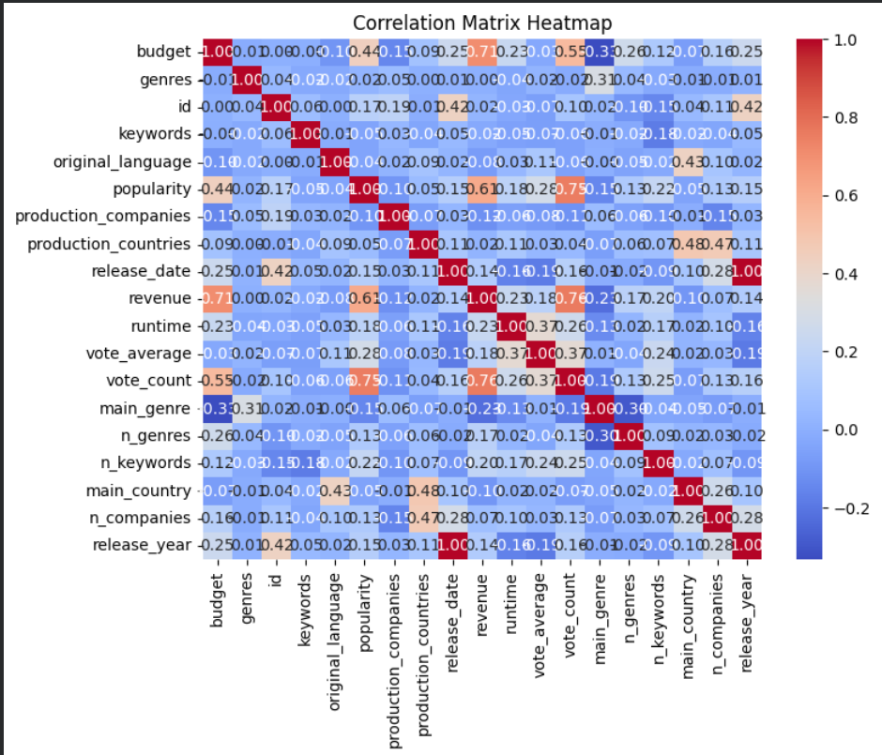

- Some visualizations of the data were created for part B to identify the relationship between popularity and revenue and budget. This helped us hypothesize what we would expect to be important features of determining most popular movies, which would help the recommendation system only select those that are highly rated.

- Scaling was not really used for the dataset, but part A split the data into training and testing sets for the classification of hit movies.

Data Cleaning and Preparation for Part A

- The main preprocessing we had to do for the data was to convert several JSON formatted columns, such as genres and keywords, into a simpler format.

- For part A, we parsed through each value to only get the important elements, such as the id and name. We created separate columns to get the count of these ids but still had the id numbers remain in the original columns, thus keeping the identification of these strings part of the dataset. Other conversions of the data, such as converting columns into datetime format and the methods listed before, were used to conform the data into only numerical data for part A’s classification model.

Part A Model

- We first created a hit_flop function to classify the movies based on revenue, budget, vote average, and popularity. The conditions to classify a movie as a hit, meaning for the function to return 1, was if the movie made more than or equal to its budget, resulting in about 2434 movies being a hit.

- A logistic model was used along with hyperparameter tuning using GridSearchCV. The resulting best fit model used the following parameters: C = 5, penalty = l2, and solver = saga. The metric evaluation results were extremely good, all ranging around .93 to .96. The confusion matrix also showed high accuracy in classifying the movies correctly, which also aligns with the resulting ROC Curve and values (.97 for train set and .96 for test set).

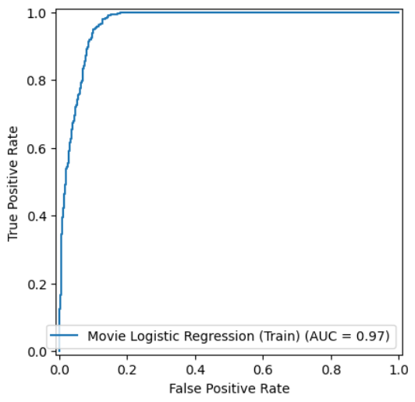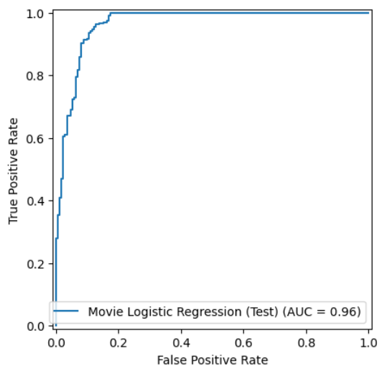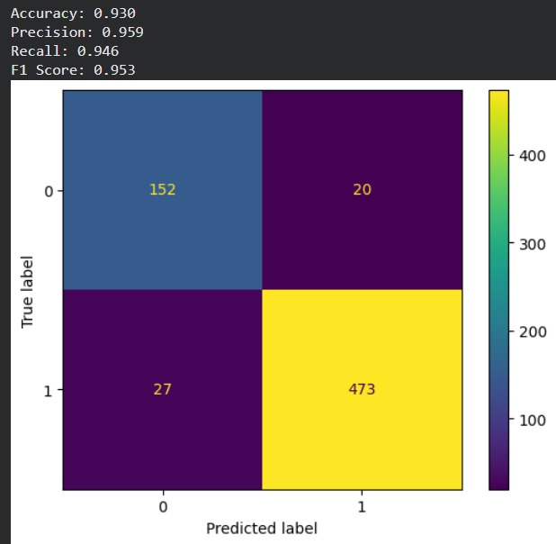

- The logistic model was able to efficiently classify a hit movie, mainly based on the popularity column, and apply it accurately to new data. If more feature engineering were involved, such as using PCA, we would be able to identify important features and include a more complex equation to the function. However, this would be left up to future discussions between directors and production companies in determining what makes a movie popular.

Part B Model
In this model we have built a content based recommendation model using TF‑IDF and cosine similarity on movie metadata, instead of a tree based or neural network model.
Data Preparation and Cleaning

- For part B of this project we have built a recommender system, so there is no 0/1 target and no class balance issue. Instead, I focused on the quality and completeness of the item features.

- Missing data: For textual metadata missing values were replaced with empty strings or lists so that the TF‑IDF vectorizer could still run. Rows with missing identifiers were dropped.

- Dealing with different data types: Object columns were first parsed from stringified JSON using literal_eval, then converted to lists of names. These lists were cleaned and concatenated into a single text soup feature. Numeric columns were mainly used for exploratory data analysis.

Scaling and Training
- Scaling: We did not apply normalization to the metadata features. TF‑IDF internally normalizes text vectors and cosine similarity does not depend on magnitude, so extra scaling was unnecessary.

- Train test split: There is no supervised target y, so no train/test split was needed. For evaluation, I conceptually treated a subset of movies as queries and measured how often their top‑K recommendations shared at least one genre with them using genre overlap as a proxy label.

Base Model
We first combined several text features (director, main cast, genres, keywords) into a single soup for each movie, then applied TF‑IDF to turn this soup into vectors. To recommend movies, we computed cosine similarity between these vectors and returned the top K most similar items.

Hyperparameter tuning and validation
Since this is unsupervised learning, we don’t have typical learnable parameters. Instead, we treated the TF‑IDF configuration and number of recommended neighbors KKK (e.g., 5, 10, 20).
as hyperparameters. We experimented with different combinations and evaluated them using a kind of item level cross validation: We split the movies into several folds. In each fold, we used the movies in that fold as query movies, recommended top K similar movies from the remaining folds, and checked how often the recommendations shared at least one genre with the query. We averaged the genre‑based precision and recall across folds to compare configurations.This gave us a way to choose reasonable TF-IDF settings and a value for KKK.

Results and Learnings:

We also inspected individual recommendation examples to see if the results made intuitive sense. For several test movies, such as Avatar, the top10 recommendations were mostly films from the same main genres and often shared similar themes, cast members, or directors.
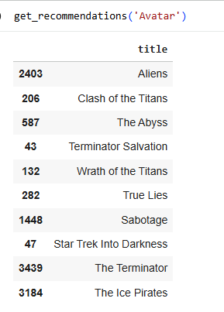
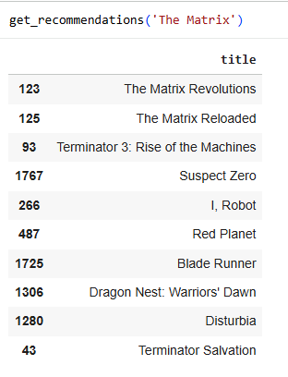
Evaluation results (K = 10)
For each movie, I took the top‑10 most similar movies (by cosine similarity on the TF‑IDF soup) and treated a recommendation as relevant if it shared at least one genre with the query movie.

The reported metrics:
Accuracy@10 = 0.810
81% of the top‑10 recommendations (across all movies) were correctly classified as relevant or not relevant according to the genre‑overlap rule.

Precision@10 = 0.810
Among all recommended movies that the model marked as relevant, 81% actually shared at least one genre with the query movie. So most of the “similar” recommendations are truly genre‑consistent.

Recall@10 = 1.000
The model successfully retrieved all genre‑relevant movies that were available within the candidate set for K = 10 under this evaluation setup. In other words, whenever a relevant movie could be recommended in the top‑10, it was.

F1‑Score@10 = 0.895
This is the harmonic mean of precision and recall, and 0.895 indicates a good balance between recommending relevant movies and not missing them.
This is the cosine similarity matrix built from the TF‑IDF vectors of the movie “soup”:
[[1. 0.07121855 0.03721726 ... 0. 0. 0. ]
[0.07121855 1. 0.03911498 ... 0. 0. 0. ]
[0.03721726 0.03911498 1. ... 0. 0. 0. ]
...
[0. 0. 0. ... 1. 0. 0. ]
[0. 0. 0. ... 0. 1. 0. ]
[0. 0. 0. ... 0. 0. 1. ]]

Each row and column represents a movie. The diagonal entries are all 1.0, because every movie is perfectly similar to itself. Off‑diagonal values (like 0.07, 0.04, etc.) represent how similar two different movies are based on their metadata. Many values are 0, which means those pairs of movies don’t share important tokens in the soup so the model sees them as unrelated.

I interpret these results as showing that my content based TF‑IDF and cosine model is quite good at recommending movies that are at least genre similar to the input movie, with high recall and a strong F1 score, while still being relatively simple and interpretable.

So overall, this project was great for us because we a learnt a lot from this:
We learned how to clean and parse heterogeneous data and engineer a textual feature space, gained hands on experience with TF-IDF vectorization and cosine similarity, and understood how high‑dimensional sparse representations encode item similarity.
We learned how to approximate classification style evaluation in a ranking setting by turning similarity scores into binary predictions and summarizing them with confusion matrix.
By inspecting recommendation screenshots, we learned to combine quantitative metrics with qualitative analysis to judge whether the model’s behavior is semantically meaningful, not just numerically good.

